**→ Application of Auto Encoders – Image Colorization**

**(1) Import library’s and give the path of images :**

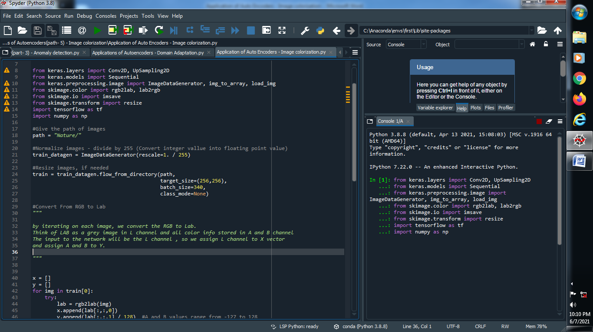

**(2) Normalize images - divide by 255 (Convert integer value into floating point value) :**

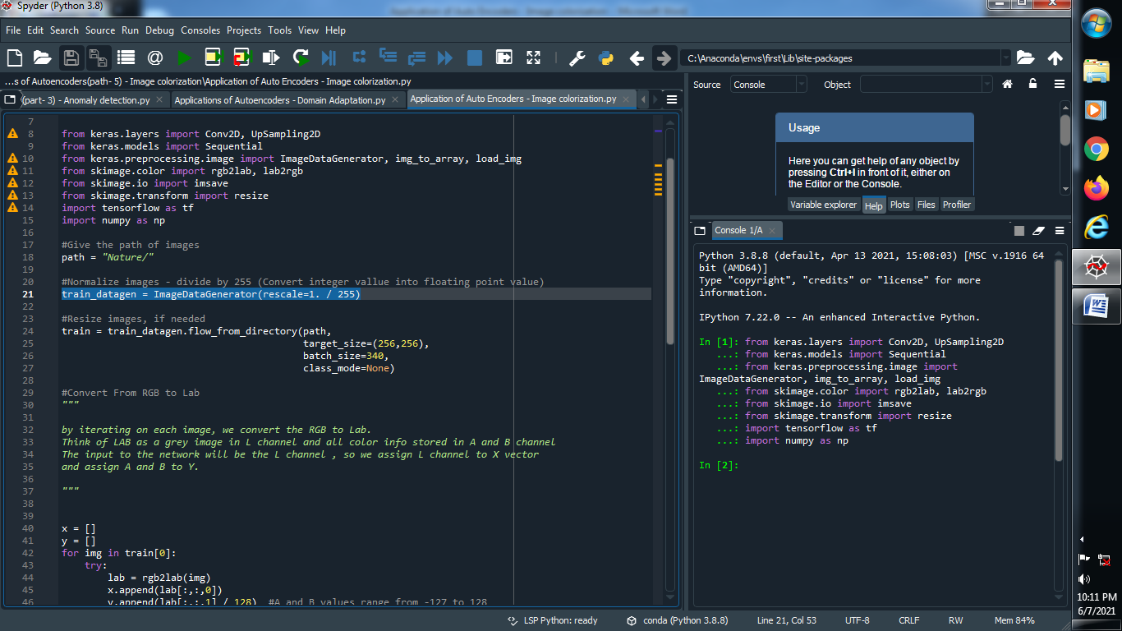

**(3) Resize our images :**

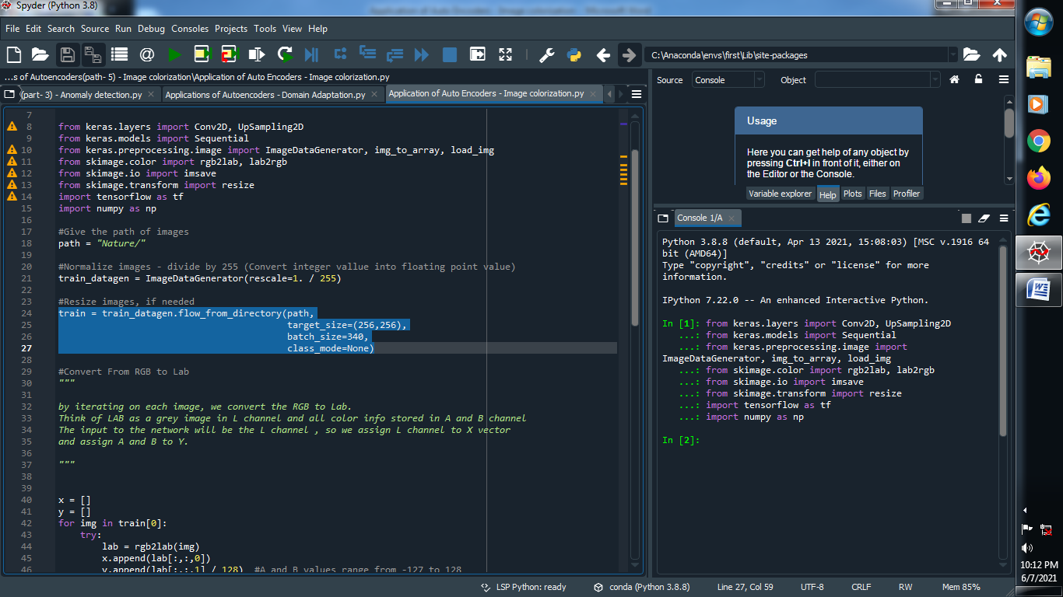

**(4) Convert from RGB to LAB :**

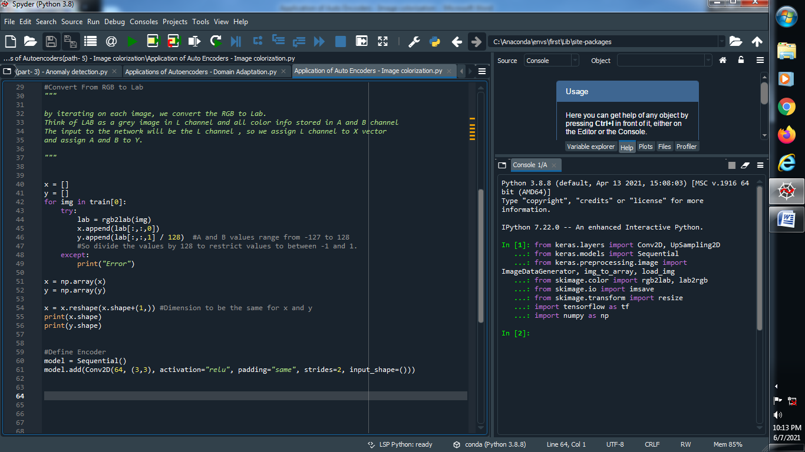

**(5) Create array for x and y and reshape it :**

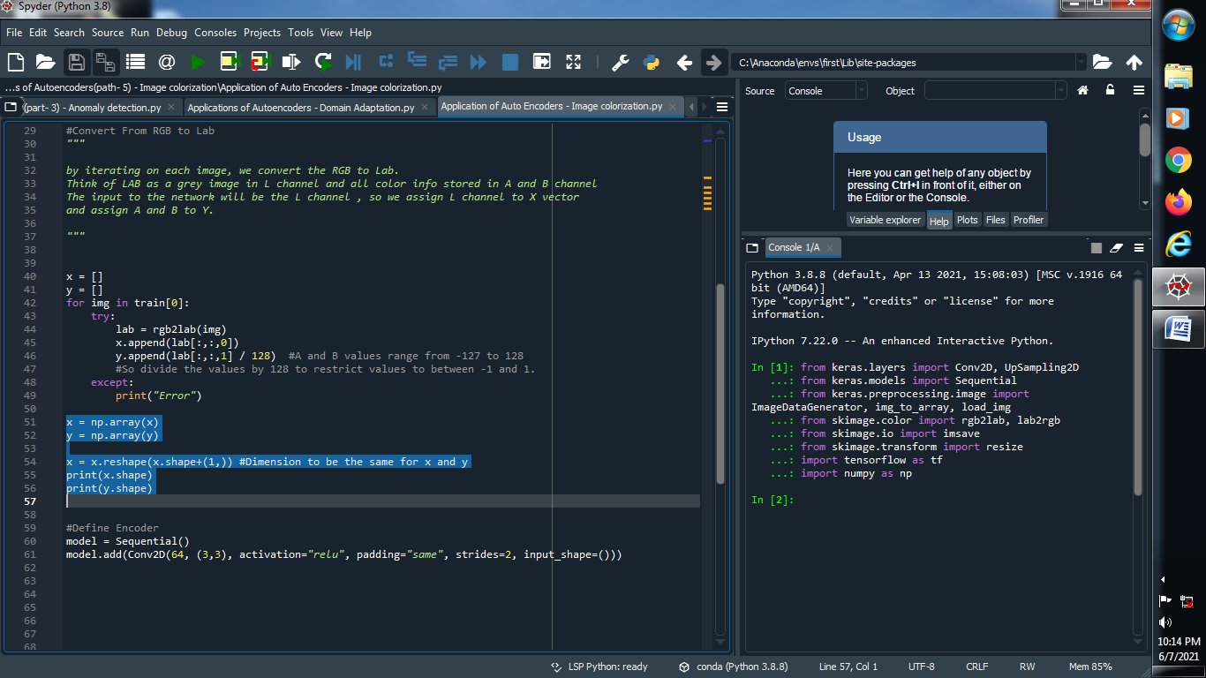

**(6) Define AutoEncoder :**

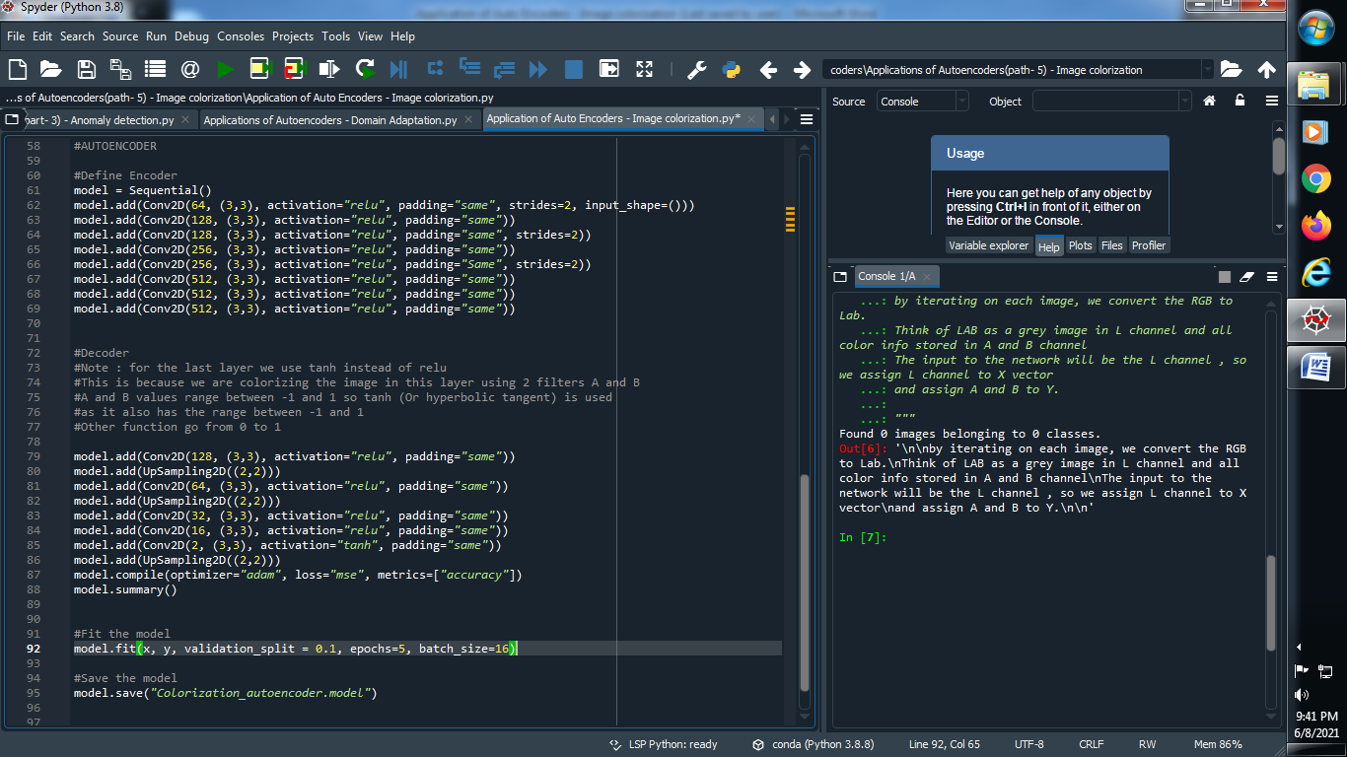

**(7) Fit the model :**

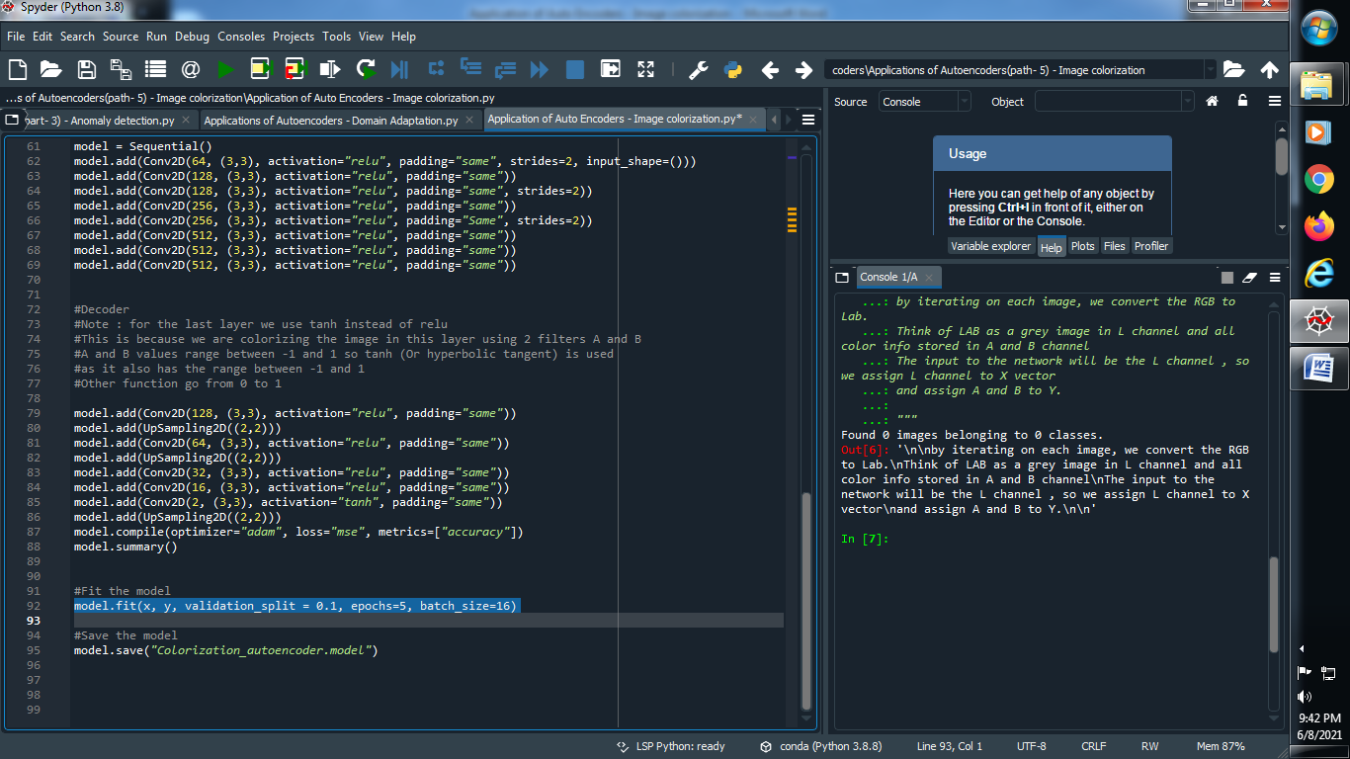

**(8) Save the model :**

